Classification of Arrhythmia by Using Deep Learning with 2-D ECG Spectral Image Representation

TEAM ID:PNT2022TMID33209

Abstract

The electrocardiogram (ECG) is one of the most extensively employed signals used in the diagnosis and prediction of cardiovascular diseases (CVDs). The ECG signals can capture **the heart’s rhythmic irregularities**, commonly known as **arrhythmias.**

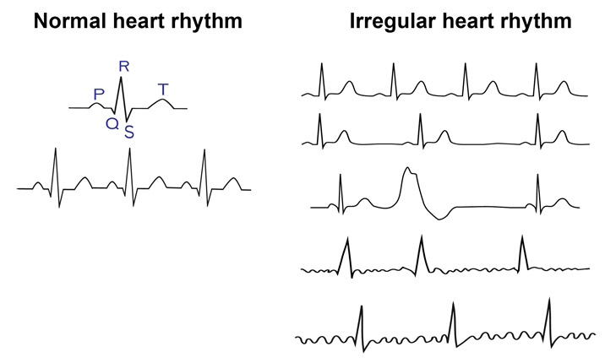

Although a single arrhythmia heartbeat may not have a serious impact on life, continuous arrhythmia beats can result in fatal circumstances.

Literature survey

In this project, we build an effective electrocardiogram (ECG) arrhythmia classification method using a convolutional neural network (CNN), in which we classify ECG into seven categories, one being normal and the other six being different types of arrhythmia using deep two-dimensional CNN with grayscale ECG images. We are creating a web application where the user selects the image which is to be classified. The image is fed into the model that is trained and the cited class will be displayed on the webpage.

Purpose

In the past few decades, Deep Learning has proved to be a compelling tool because of its ability to handle large amounts of data Convolution al Neural Networks. In deep learning, a convolutional neural network (CNN/ConvNet) is a class of deep neural networks, most commonly applied to analyze visual image.

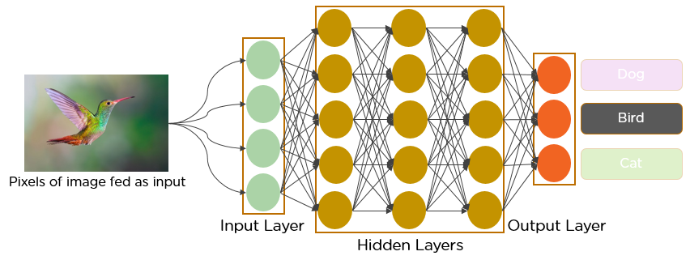

Existing Problem

Cardiovascular diseases (CVDs) are the number one cause of death today. Over 17.7 million people died from CVDs in the year 2017 all over the world which is about 31% of all deaths, and over 75% of these deaths occur in low and middle-income countries. Arrhythmia is a representative type of CVD that refers to any irregular change from the normal heart rhythms. There are several types of arrhythmia including atrial fibrillation, premature contraction, ventricular fibrillation, and tachycardia.

# Proposed solutions

* Electrocardiogram
* Ambulatory monitors
* Tilt table test
* Cardiac catheterization
* Echocardiogram

Software components used

The proposed CNN classiﬁer was implemented in Python with the open source library TensorFlow which was developed by Google for deep learning. Substantial computational power and training time were needed to train the CNN model.

Experimental Setup

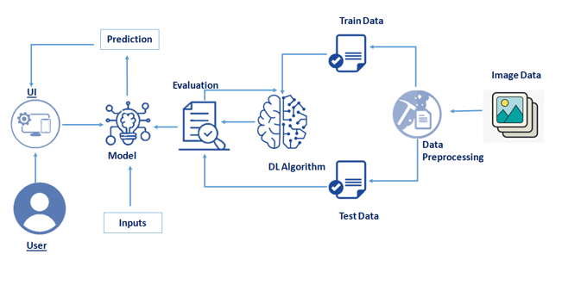

In this project, we have deployed our training model using CNN on deeplearning and in our local machine. We are deploying 4 types of CNN layers in a sequential manner

Convolutional layer 2D:

A 2-D convolutional layer applies sliding convolutional filters to 2-D input. The layer convolves the input by moving the filters along the input vertically and horizontally and computing the dot product of the weights and the input, and then adding a bias term.

Pooling Layer :

Pooling layers are used to reduce the dimensions of the feature maps. Thus, it reduces the number of parameters to learn and the amount of computation performed in the network. The pooling layer summarises the features present in a region of the feature map generated by a convolution layer.

Fully-Connected layer :

After extracting features from multiple convolution layers and pooling layers, the fully-connected layer is used to expand the connection of all features. Finally, the SoftMax layer makes a logistic regression classification. Fully-connected layer transfers the weighted sum of the output of the previous layer to the activation function. Dropout Layer :

There is usually a dropout layer before the fully-connected layer. The dropout layer will temporarily disconnect some neurons from the network according to the certain probability during the training of the convolution neural network, which reduces the joint adaptability between neuron nodes, reduces overfitting, and enhances the generalization ability of the network.

Advantages:

The proposed model predicts Arrhythmia in images with a high accuracy rate of nearly 96% The early detection of Arrhythmia gives better understanding of disease causes, initiates therapeutic interventions and enables developing appropriate treatments. Disadvantages:

* Not useful for identifying the different stages of Arrhythmia disease.
* Not useful in monitoring motor symptoms

Applications

* It is useful for identifying the arrhythmia disease at the early stage
* It is useful in detecting cardiovascular disease.

Conclusion

Cardiovascular disease is a major health problem in today's world. The early diagnosis of cardiac arrhythmia highly relies on the ECG. Unfortunately, the expert level of medical resources is rare, visually identify the ECG signal is challenging and time-consuming.